# Practical 1 Study of HTML tags. Design HTML page using basic tags.

<html>

<head> <title> </title> </head>

<body bgcolor="cyan">

<h3>Kaustubh Wade(160410116050)</h3>

<p>This paragraph is written inside paragraph tag.</p>

<br>

<hr>

<h1>Heading 1</h1>

<h2>Heading 2</h2>

<h3>Heading 3</h3>

<h4>Heading 4</h4>

<h5>Heading 5</h5>

<h6>Heading 6</h6>

<font color="white" size="5">This text is written with size 5 in white colour</font> <br><br>

<i>This text is written inside italic tag.</i> <br>

<b>This text is written inside bold tag.</b> <br>

<u>This text is written inside underline tag.</u> <br>

<em>This text is written inside emphasis tag.</em> <br>

<tt>This text is written inside typewriter-text tag.</tt> <br><br>

Text<sup>This text is written inside Superscript tag.</sup> <br>

Text<sub>This text is written inside Subscript tag.</sub> <br>

</body>

</html>

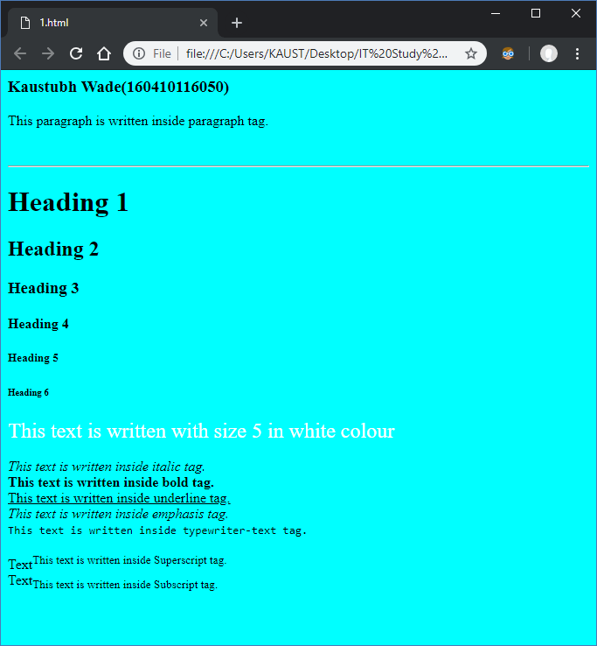

<html>

<head> <title> </title> </head>

<body>

<h3>Kaustubh Wade(160410116050)</h3> <br>

<a name="top">This is the top of this Web Page</a>

<br> <br>

<br> <br>

<a href="#bottom">Click here to go to the Bottom of this page</a>

<br> <br>

<br> <br>

<a href="2.1.html">Click here to open link</a>

<br> <br>

<br> <br>

<a href="2.1.html" target="_blank">Click here to open link in new Tab</a>

<br> <br>

<br> <br>

<a href="2.1.html#skipcontent">Skip to Main Content</a>

<br> <br>

<br> <br>

<a href="#top">Click here to go to the Top of this page</a>

<br> <br>

<br> <br>

<a name="bottom">This is the Bottom of the page</a>

</body>

</html>

